1/3 INCH COLOR HI. RESO. IR CAMERA, 24PCS LED, 540 TVL

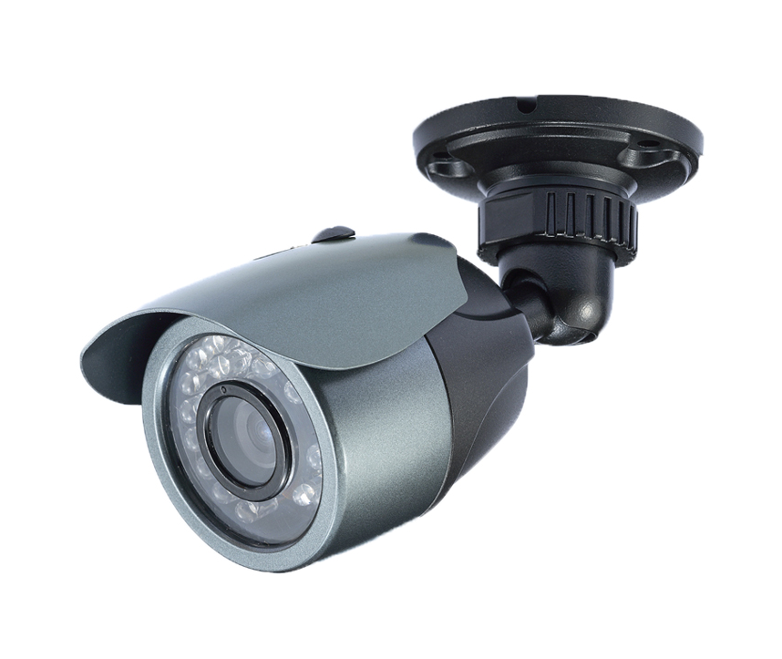

S P E C I F I C A T I O N S

1/3 INCH COLOR HI. RESO. IR CAMERA, 24PCS LED, 540 TVL

MODEL NO.: C4853-62BABR1-2 (NTSC) / C4854-62BABR1-2 (PAL)

PICK-UP SIZE: 1/3 INCH HI. RESO. HAD SENSOR
SIGNAL MODE: NTSC PAL
VERTICAL FREQUENCY: 59.94 Hz 50 Hz
PICTURE ELEMENTS: (HxV) 768 x 494 (NTSC) 752 x 582 (PAL)
HORIZONTAL FREQUENCY: 15.734 KHz 15.625 KHz
SYNC. MODE: INTERNAL
SCANNING SYSTEM: 2:1 INTERLACE
MINIMUM ILLUMINATION: 0.02 LUX, F=1.2 (DAY), 0 LUX (IR ON)
HORIZONTAL RESOLUTION: 540 TV LINES
S/N RATIO: MORE THAN 48dB (AGC OFF)
GAMMA CHARACTERISTIC: r = 0.45
GAIN CONTROL: AUTO
WHITE BALANCE: AUTO
ELECTRONIC SHUTTER: NTSC: 1/60s to 1/100,000s, PAL: 1/50s to 1/100,000s AUTO
LENS FURNISHED: BOARD LENS f3.6mm / F2.0 (OPTION: 4.3 / 6.0 / 8.0 / 12mm)
VIDEO OUTPUT: COMPOSITE 1.0 Vp-p AT 75 OHMS
IR LED: 24PCS IR LED
WAVE LENGTH: 850 nm
BEAM SPREAD: 35°
PROJECTION DISTANCE: 20 M
LED LIFE: 6000 HRS
ILLUMINATOR ACTIVE LIMIT: 10 LUX
POWER REQUIREMENT: DC12V ± 10%
POWER CONSUMPTION: 315mA MAX. (IR ON)
95mA MAX. (IR OFF)
OPERATING TEMPERATURE: -10°C to +50°C
APPROVAL: IP 68
DIMENSIONS: 62(Φ) x 142(L)mm
WEIGHT: 450g

